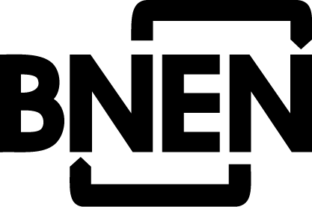
ID Picture
Belgian Nuclear higher Education Network

Academic Year 2022-2023

Unique year Unique year bis Part I Part I bis Part II Part II bis

Registration form

TO SEND BACK NOT LATER THAN
MARCH 15, 2022 (International students) / June 15, 2022 (Belgian students)

Please complete this form and send it to

Kris Pennemans:
SCK CEN, Boeretang 200, B-2400 Mol,
E-mail: bnen@sckcen.be

APPLICANTS DATA
Private data
Last Name: First Name: Prof. Dr. Mr. Ms.
Private address:
Zip: Town: Country:
Place of birth: Date of birth: Nationality:
Passportnumber: Date of Issue: Valid till:
National register no.:
Professional data
Company: Address:
Position at company:
Zip: Town: Country:
Phone: Fax: E-mail:
University in which you intend to enroll
○ UGent ○ KULeuven ○ VUB ○ ULB (= referent university French speaking universities ULB/ULg/UCL)
Please use capitals.

Hereby I apply for registration in the BNEN “Belgian Nuclear higher Education Network”. I accept that my application is subject of a selection procedure, and may be refused, if the steering committee decides so, due to any reason. I understand that my travels to Mol (Belgium) and back, my accommodation, my insurances, and the acquisition of the necessary visa have to be arranged and paid individually if I will be selected for participation.

The following documents are attached to my application:
1) A Curriculum Vitae (English knowledge must be stated).
2) A list of courses followed during the university studies. A short description of the content of the following courses: mathematics and physics.
3) A statement about the way of the coverage of the costs of my participation (own sources, home university, grant, fellowship, etc.).
4) A copy of your degree(s).
5) We advise students to provide us a GRE (Graduate Record Evaluation) score. It will help us to make a decision about your application.
6) Proof of registration at the university

Date: Signature: N/A (electronic)

